

**SOUTH WEST ROCKS**

**KIDS CLUB SCHEDULE**

**JULY 2024 SCHOOL HOLS**

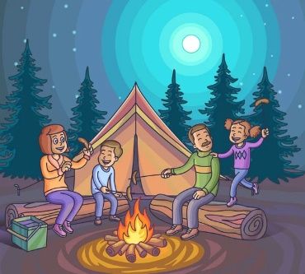

|  |  |  |  |  |
| --- | --- | --- | --- | --- |
| **DATE** | **TIME** | **ACTIVITY** | **VENUE** | **COST** |
| Mon 8/7 | 2.30pm | Chocolate Bingo | Games Room | Free |
| Tues 9/7 | 2.30pm | Naidoc Week Craft | Games Room | Free |
| Thurs 11/7 | All Day | Scavenger Hunt | Get forms from Reception | Free |
| Tues 16/7 | 5pm-7pm | Live music with Richie Gudgeon  Free Sausage Sizzle & Fire Pits to keep you warm.  BYO Chairs, Blanket, Nibbles & Drinks | Western BBQ Area near Jumping Pillow | Free |
| Wed 17/7 | From 7.30pm | State of Origin on the BIG SCREEN | Games Room | Free |
| Thurs 18/7 | All Day | Street chalk art – collect your chalk from Reception | At your site | Free |

